
COMSATS University Islamabad, Virtual Campus

MGT 403 Entrepreneurship

Lecture 27 Handouts

INFLUENCING and NEGOTIATION

Influencing
Management is about getting things done, meeting objectives set in line with those of organisation, to get the things done management is influencing or imposing their will upon others, people may or may not be willing but they need to work towards a common goal, there cud be two extremes ‘carrot or stick’ but there are many options in between, following are some influencing strategies
- Reason
- Friendship
- Coalition
- Higher Authority
- Sanctions

Negotiation
‘Negotiation is a process in which individual or groups seek to reach a goal by making agreements with others’.
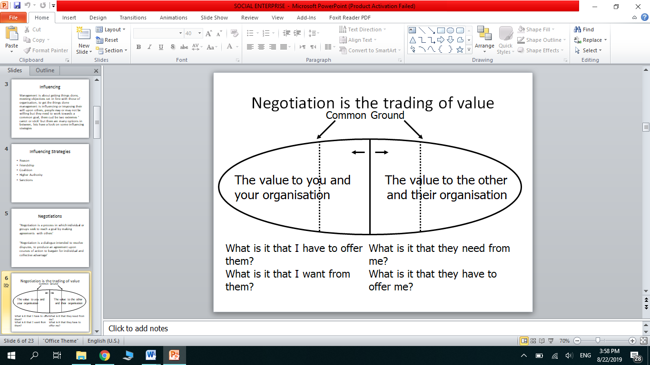
‘Negotiation is a dialogue intended to resolve disputes, to produce an agreement upon courses of action to bargain for individual and collective advantage’.

Negotiation Strategies
The negotiation strategies are as below:
- Hard Bargaining
- Soft Bargaining
- Principled Bargaining
- Hard Bargaining
Following are the characteristics of hard bargaining.
- Gives away nothing.
- See participant as adversaries
- Hard sell and take-it-or-leave-it.
- Distrust others
- Play sneaky games to get negotiating advantage
- May use physical presence/threats
- Two hard bargainers may end up both loosing

- Soft Bargaining
Following are the characteristics of soft bargaining.
- Agreeable & Flexible.
- Treating the participant as friends
- Seeking agreement at any cost
- Honest about their bottom line
- Leaves them to vulnerable to hard bargainers

- Principled Bargaining
Following are the characteristics of principled bargaining.
- Separate the people from the problem
- Focus on interests, not positions.
- Generate options for mutual gain.

Types of Negotiation:
Now when it come to the strategies o bargaining. There are two types of bargaining.

- Distributive (win-lose): no scope for trade-offs on the basis of different preferences or goals. Negotiation is a zero-sum game where one side wins and the other side loses.
- Integrative (win-win): the scope for trade-offs is determined on the relative importance of different factors to each party. Any negotiation involving a range of factors is potentially integrative because the parties will probably place different levels of importance on various aspects.

Planning to negotiate
- Establish your objectives
- Map other party’s objectives
- Frame negotiation as a joint search for a solution
- Identify areas of agreement
- Trouble shoot disagreements: bargain & seek alternative solutions, introduce trade offs
- Agreement and close: summarise and ensure acceptance


Team Roles in Negotiating Team
- Lead Negotiator
Negotiations cannot be done by committee; there needs to be somebody leading the negotiating team. This means assigning roles, delegating tasks, making the decisions necessary for what positions will be offered at the table, and selecting which negotiated proposals should be forwarded to a decision-maker. It is important for the lead negotiator to remember that his or her title does not mean "the person who talks the most at the negotiating table." Like a conductor for a symphony orchestra, the leader doesn't play every instrument; rather, he or she makes sure everyone is well-practiced, on the same sheet, and playing to the right tempo.
- Number Cruncher
When negotiations require complex pricing/cost analysis (i.e.,Long-Term contract),there must be a person who knows the number in the room. It plays very important role in accessing the benefits to the company in numeric term.
- Note Taker
Both sides must take notes of each meeting. Each team should designate a person to take notes. This is a very important step in the negotiations process. Not only does taking notes help you remember what was discussed each night, but your notes also become your document of proof in the case of a disagreement with the other side as to what was agreed upon. If your notes are disorganized, incomplete or don't include all important information, you will not be prepared.
Tips for Note Taking in Negotiations:
- Note who was taking the notes
- Note the time that the meeting starts and stops
- Record who was present for the meeting from each side
- Note if and when a break or caucus was taken
- State each provision that was discussed
- Record all proposals given and the key points of each proposal
- Record each side's response to the proposals
- Do not try to take verbatim notes of the conversation. Record only key points.
- Time Keeper
A timekeeper in a meeting is a person who takes on the role of measuring or recording the amount of time taken to do something. The timekeeper essentially helps the facilitator move the group through the agenda, reducing the amount of stress on the facilitator or leader who is managing the discussion.

Factors for success
In any kind of negotiation, success depends on few factors. Following is the list which can be reviewed prior to negotiation.
- Legitimacy of your case
- Confidence in presenting it
- Courtesy to the other party
- Adaptation to the other party’s style
- Rapport
- Incentives and trade offs
- Research the bigger picture

Tips on Negotiation:
- Aim high to begin with – easier to lose ground than gain
- Give concessions ‘reluctantly’
- Break down complex deals
- Language:
  - Make proposals with open questions such as:
    - “what would happen if we…?”
    - “suppose we were to…”
    - “what would be the result of?”
  - Dealing with stone-walls: “what would need to happen for you to be willing to negotiate over this?”
- Always get agreement in writing

What is a Social Enterprise?
According to the Social Enterprise Coalition, Social Enterprises are…
“…businesses trading for social and environmental purposes. Social enterprises are distinctive because their social and/or environmental purpose is absolutely central to what they do - their profits are reinvested to sustain and further their mission for positive change.”
“We have described and keep on describing organizations motivated by social objectives as non-profit organizations. We need to have another description: ‘non-loss ’organizations, because we don’t want to lose money and our objective is to address a particular problem. So we are non-loss businesses with social objectives.”
Muhammad Yunus. Founder of the Grameen Bank, Bangladesh
Example of Social Enterprise
The Social Enterprise movement first emerged 1840s. In Rochdale, a workers' co-operative was set up to provide high quality affordable food in response to factory conditions that were considered to be exploitative.
Key Points:
- A social enterprise is a business with social objectives that serve its primary purpose.
- Maximizing profits is not the primary goal of a social enterprise as is with a traditional business.
- Unlike a charity, social enterprises pursue endeavors that generate revenues, which fund their social causes.
- Regarding employment, preference is given to job-seekers from at-risk communities.

The Process of Social Entrepreneurship
- Find an opportunity
- Develop a business concept
- Figure out what success means and how to measure it
- Acquire the right resources
- Launch and grow
- Attain goals

Characteristics
Social Enterprises:-
- Operate as commercially run businesses
- Aim to make profits
- Generate the bulk of their income through sales of goods or services
- Use good business practices and principles
- Use the majority of their profits to further social or environmental goals
- May hold the Social Enterprise Mark
Key Differences
Explicit Social Aims (Triple Bottom Line) | Private sector business primarily focus is on trading; social enterprises too have a commercial focus but will also have an explicit social and/or environmental purpose.
Funding | Social enterprises often have a complex composition of sales income, commercial contracts, service level agreements and grant support.
Risk | Social enterprises are usually governed by a Board of volunteers, which may mean that they are more risk averse in terms of pursuing business ventures.
Scale | Start up costs may be much higher because social enterprise usually has to operate on a scale that is large enough to sustain its social commitment from the beginning
Investment | Social enterprises may have difficulty gaining access to traditional forms of investment such as loan finance.
Leadership / Entrepreneurship | Leaders of social enterprises are usually driven by the social potential of the venture and will need to find support for the other areas of the enterprise
Stakeholders | Social Enterprises usually have a wide range of stakeholders involved in their development, which can mean that there is a wide influence on the development process.

Source: https://www.extraordinaryteam.com/team-negotiations-require-much-planning/
https://www.lucidmeetings.com/glossary/timekeeper#:~:text=A%20timekeeper%20in%20a%20meeting,who%20is%20managing%20the%20discussion.
https://www.investopedia.com/terms/s/social-enterprise.asp#:~:text=A%20social%20enterprise%20or%20social,used%20to%20fund%20social%20programs.
https://www.cimaglobal.com/Documents/ImportedDocuments/cid_tg_negotiation_mar07.pdf.pdf

